Name – Kent Orchard
ST10258582
Assessment WL Project
Milestone 1

Milestone 1
Each individual member of the group must write a report on their recommendation of a web page and mobile application based on the given scenario (above). Motivate why you have chosen your design and the functionality you have incorporated into the mobile app and webpage. Include wireframes for your web page and mobile app. You must also design a logo which reflects the purpose of the business. It should be eye- catching and not too complicated. Use a user-centred design process to design your webpage and mobile app.
Website Wireframe
Home Page:
- Header with "Empowering the Nation" logo.
- Brief explanation of the enterprise's mission and vision.
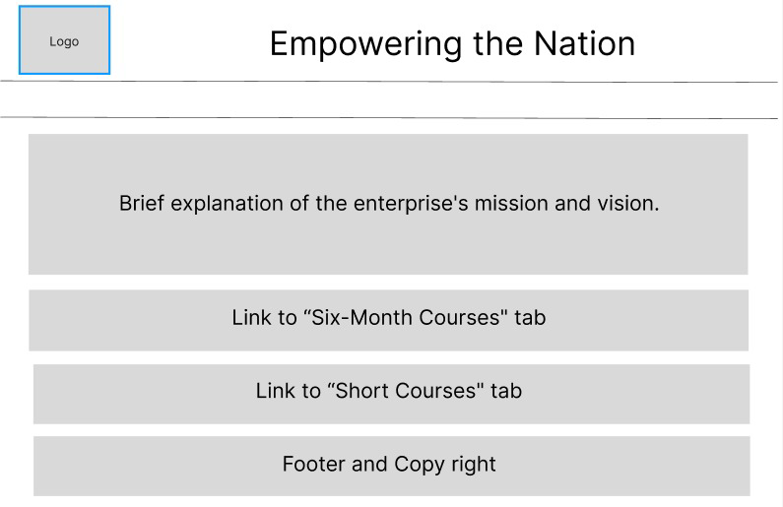
- Buttons or links to "Six-Month Courses" and "Short Courses."

Six-Month Courses Page:
- List of six-month courses with names and fees.
- Hyperlinks to individual course details pages.
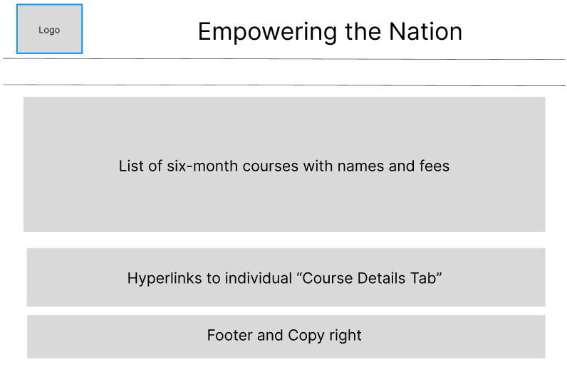

Short Courses Page:
- List of short courses with names and fees.
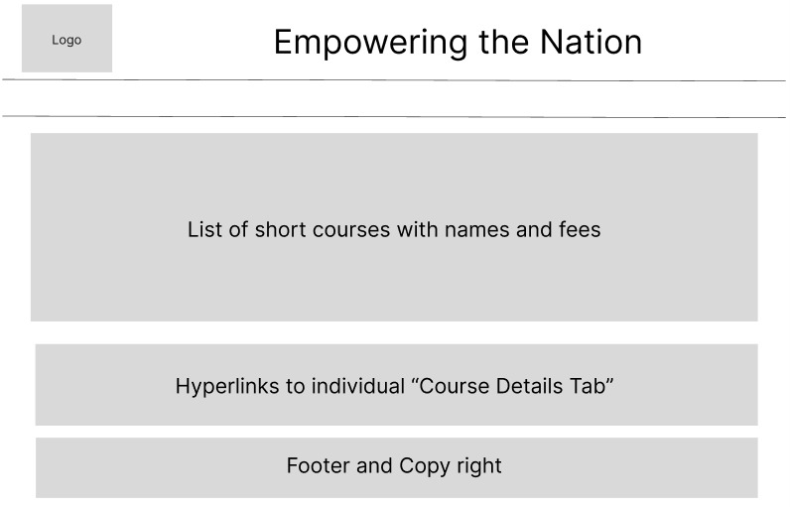
- Hyperlinks to individual course details pages.

Course Details Page (General Structure):
- Course Title at the top.
- Purpose of the course.
- Course Content details.
- Fee: R1500 (course fee).
- "Register" button to proceed with course registration.
Calculate Total Fees Page:
- Contact details form (Name, Phone, Email).
- List of courses with checkboxes and corresponding fees.
- "Calculate Total Fee" button.
- Display of the total fee including discounts and VAT (15%).
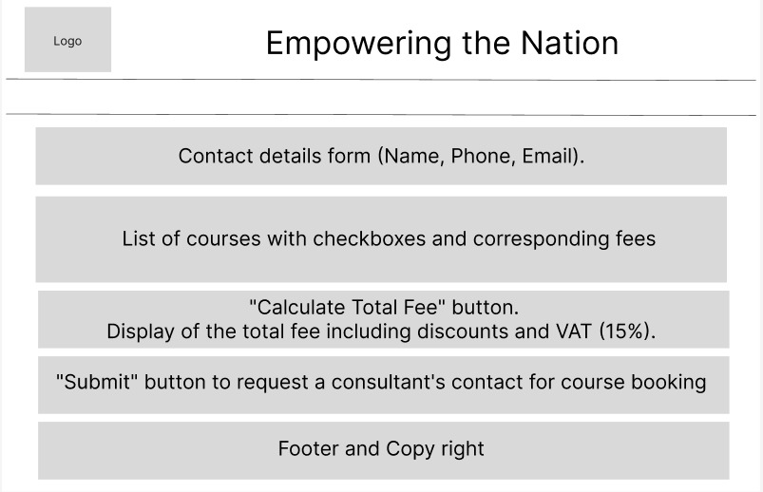
- "Submit" button to request a consultant's contact for course booking.

Contact Details Page:
- Phone number, email address, and addresses of Johannesburg venues.
- Optionally, maps for each venue.
Navigation:
- Include a persistent navigation menu with links to different sections (Home, Six-Month Courses, Short Courses, Contact).
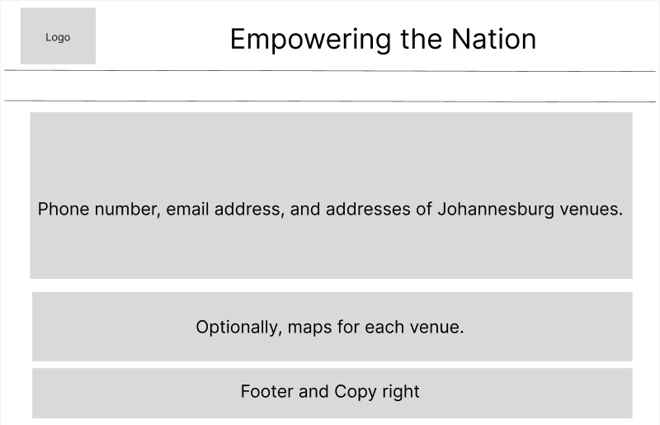
Logo :


Website and App Design

Our website's color scheme embodies our company's essence with subdued hues, including muted olive greens that signify sustainability, dusty blues representing trust and growth, and muted grays for neutrality and strength. These colors collectively reflect our commitment to progress, stability, and a minimalist yet impactful approach.

Content of the Website

We shall present a concise outline of the company's mission and emphasize the significance of skilled workers. Additionally, we will incorporate a clickable button that guides users to learn more about the programmes, accessible through the "Programmes" tab. We intend to establish a section that outlines the available courses, offering comprehensive descriptions of both the month-long Learnerships and the six-week Short Skills Training Programmes.

Our plan involves narrating the history of "Empowering the Nation," elucidating its founders and the motivating factors driving its inception. We will shine a spotlight on the notable progress the organization has achieved thus far. Encompassed within our presentation will be the advantages of the courses, the curriculum details, and feedback from past trainees.

Furthermore, we will furnish contact details, including a contact form, as well as a map pinpointing the location of the training center in Johannesburg.

Mobile App Features

Within our application, we will enable users to create profiles, facilitating the monitoring of their progress, acquisition of course materials, and receipt of company updates. A designated tab will offer users the ability to explore and opt for courses, peruse course schedules, and enroll in their preferred programs.

Another tab will encompass a functionality allowing prospective customers to solicit quotations for specialized services and sign up for the respective courses. Furthermore, we plan to introduce a dedicated section where trainees can impart their success and recount their experiences post course completion.

User Experience

Our Website and Mobile App will be designed so that it creates a User-friendly environment in which anybody will be able to use. Both the Website and the Mobile App will be fast and responsive, this will uphold our image with these elements included in them. It will create a pleasant experience for our customers.

Extra imformation

Our design and company name

Rise



